COMPLIMEMTS, COMPLAINTS AND APPEALS PROCEDURES
There are requirements under law to have a complaints procedure in place when educating young people. The protocol needs to be fully understood by all parties when young people are working off site. The following protocol is the agreed means of dealing with complaints and managing compliments.
- All complaints from learners or parent/carers about curriculum, travel, provision, teaching, staff, etc should be made initially be made by phone but can be put in writing, should the need arise.
- A register of complaints/compliments will be kept together with response times and outcomes.
If a parent/carer has a complaint regarding a concern in the school, they should follow the outlined procedure which is based on the line management system:
Teacher/other member of staff
Head of Department/Head of Year/Line Manager
Headteacher
Chair of Governors
Panel Hearing
After the Chair of Governors stage, the Governors have detailed policies regarding appeal procedures should these be needed and the local authority can be contacted.

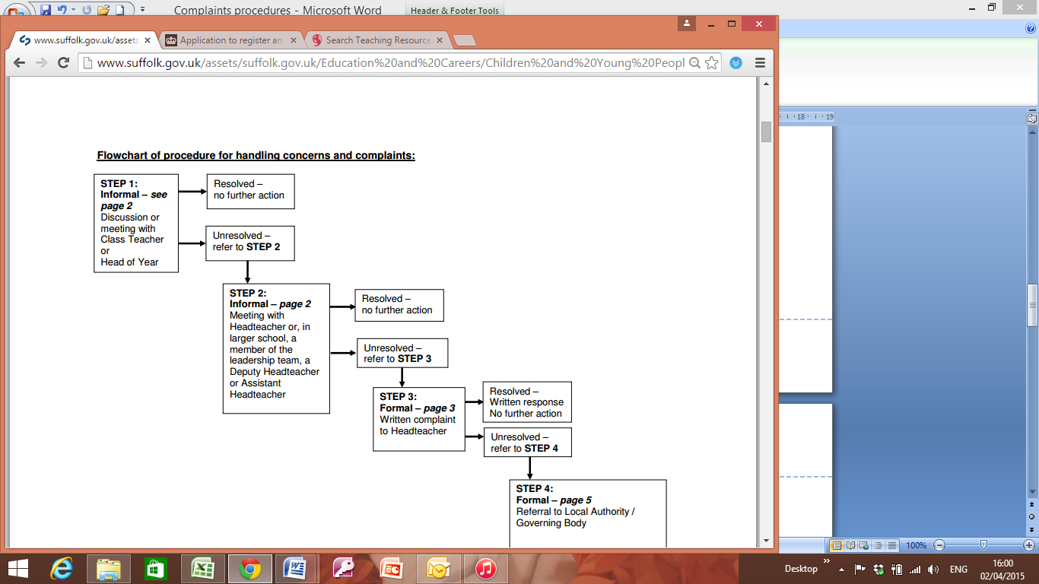
+ Panel Hearing

STEP 1: Informal
Please start by telling the class teacher or head of year about your concern. This is usually the best and quickest way of resolving issues. • It is recommended that you make an appointment to speak to the class teacher or head of year as soon as possible as this will give both parties the opportunity to talk about the issue in an appropriate manner and without being interrupted.
• The purpose of this meeting should be to establish the nature of the concern and to seek a realistic resolution to the problem. • It is good practice for the class teacher or head of year to make a brief written record of the concern raised and any actions agreed.
STEP 2: Informal
If you feel dissatisfied with the outcome of discussions with the class teacher or head of year, please ask for an appointment to meet with the Headteacher or, in a larger school, a member of the leadership team, a Deputy Headteacher or Assistant Headteacher. • The purpose of this meeting should be to establish the nature of the ongoing concern, what has been discussed with the class teacher so far and any actions arising from the initial meeting • It is in everyone’s interest, particularly the child or children, for concerns to be sorted out quickly and smoothly. • It is good practice for the Headteacher or leadership team member to make a brief written record of the concern discussed and what has been agreed and to write to parents summarising this. It is hoped that most problems will have been resolved at this stage through the informal process.
STEP 3: Formal - complaint letter to the Headteacher If you feel that the issue you have raised has not been resolved through the informal process and you wish to pursue it further you may raise it through the formal procedure. To do this you must write a formal letter of complaint to the Headteacher (you may use the form below - Appendix 1). Your letter should set out clearly the concern which has previously been discussed and why you feel that the issue is unresolved. It is also helpful if you can set out in your letter what resolution you are seeking. • Moving to the formal complaints procedure is a serious step. In consideration of future home/school relationships everyone concerned will need to concentrate on finding a resolution to the issue and negotiate an agreement as to how this can best be achieved. • The Headteacher will consider the complaint and in doing so should establish what has happened so far, and who has been involved; clarify the nature of the complaint and what remains unresolved; meet or contact you if they need further information; o clarify what you feel would put things right if this has not been set out in your letter; o interview those involved in the matter and/or those complained of, allowing them to be accompanied if they wish; • conduct any interview with an open mind and be prepared to persist in the questioning; • keep notes of any interview for the record.
• The Headteacher will keep in mind ways in which a complaint can be resolved. It might be sufficient to acknowledge that the complaint is valid in whole or in part. In addition, it may be appropriate to offer one or more of the following •an apology; • an explanation; • an admission that the situation could have been handled differently or better (n.b. this is not an admission of negligence); • an assurance that the event complained of will not recur; 4 o an explanation of the steps that have been taken to ensure that it will not happen again; • an undertaking to review policies in light of the complaint.
It may also be the case that the complaint may not have any substance and is therefore considered to be unfounded or unsubstantiated. • The Headteacher will discuss the outcome of their consideration of your complaint with you and should send a detailed written response within 20 school days. Where this proves unrealistic you will be informed in writing and given an estimate of how long it will take to provide a detailed response. Concerns or complaints specifically about the Headteacher Where you are unhappy about the decision the Headteacher has made about your complaint, this does not become a complaint about the Headteacher. If you feel that the complaint has not been resolved you should move to Step 4 of the procedure.
If you have a concern or complaint that is specifically about the Headteacher and which has not been resolved at the informal stage, then you must write a formal letter of complaint to the Chair of Governors. The school will provide you with the Chair of Governors’ name and you should write to him or her at the school address, marking the envelope ‘urgent, private and confidential’. • The Chair of Governors should acknowledge receipt of the letter within 5 school days and contact the Area Officer, Learning and Improvement at the Local Authority for advice.
STEP 4: Formal / Panel
Complaints not resolved through the formal procedure. If you believe that the school has not properly followed its complaints procedure or has not acted fairly or reasonably in responding to your complaint you may refer the matter to the Local Authority. The Local Authority has no legal right or duty to deal with most complaints about schools but will provide advice to the parent/carer and governing body in the event that a complaint which has been considered under the formal procedure remains unresolved or if the complaint is specifically about the Headteacher. You will need to write to the Local Authority giving the details of your complaint, what action you have already taken to try and resolve your complaint and attaching a copy of the written response from the school.
• The Local Authority will contact you to confirm the details of your complaint and seek further information where necessary. • Initial consideration will be given to the circumstances of the complaint and the procedure followed by the school. • The Local Authority will come to a recommendation – either: • that a thorough investigation has been fairly undertaken by the school and that an appropriate response has been made in accordance with the findings; or • that the complaint merits further investigation (it will be referred back to the school in this case) • The Local Authority will notify you in writing of the recommendation and what will happen next.
Stage Four: Appeal
If the complainant remains dissatisfied at after Stage four investigations, the Principal will make provision for a hearing before a Panel, appointed by or on behalf of the Principal. This Panel will consist of at least three people who were not directly involved in the matters detailed in the complaint. At least one person on the Panel will be independent of the management and running of the school. You will be informed about when the hearing is and may attend, as well as be accompanied, if you wish to do so.
The Panel will consider the complaint and document its findings and recommendations, making these findings and recommendations available for inspection on the school premises by the Principal. Once the hearing has been completed, the outcome and a copy of the findings and recommendations will be provided to all parties, including the complainant and where relevant, any person complained about, in writing within 20 working days.

Record Keeping
Blessed Education will maintain a written record of all complaints, whether they are resolved following a Stage Two investigation or proceed to Stage Four appeal, including the action taken as a result of those complaints (regardless of whether they are upheld). All documentation relating to a complaint, including correspondence, statements and records, will be kept confidential (except where the Secretary of State or a body conducting an inspection under section 109 of the 2008 Act requests access to them)
Further Action
On conclusion of Step 4, you may ask for your complaint to be heard by a committee of the governing body. The Local Authority officer will advise you how this can be arranged. Finally, if on conclusion of all 4 steps of this procedure you feel that the school’s governing body and/or the Local Authority has acted unreasonably you may make a complaint in writing to the Secretary of State for Education. You may contact the Department for Education

Prepared: September 2019
Review: September 2021

Appendix – complaints/ comments form
Compliments and comments will be acknowledged and used for improving the education service.

Compliments/Complaints/comments
Should you wish to make any compliment/complaint/comments about the School Services please use this form:

Constructive compliments/complaints/comments will enable the School to identify and acknowledge good work or improve the quality of the service and staff training. Your views are therefore valuable to us.

Name of Person making the
Compliment/Complaint/Comments:
Name of person: ____________________________________________________________________

Nature of Compliment/complaints/comments (delete accordingly)

Please give details (please continue overleaf if necessary):

Signature of person making compliment/complaint/comments:

Date:

